

**FLU SEASON IS HERE**

**PROTECT YOURSELF AND YOUR LOVED ONES**

**CALL SCOTT COUNTY HEALTH DEPARTMENT AT**

**(812) 752-8455 TO SCHEDULE YOUR FLU SHOT**

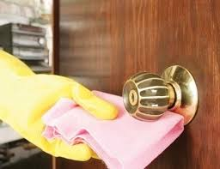

**How can you protect your home and office?**

The flu can live on certain surfaces for up to 48 hours. Clean surfaces such as doorknobs and countertops around your home and work with a disinfectant.

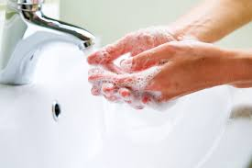

**How do you handle items that have possibly been contaminated by the flu virus?**

**HANDWASHING AND DISINFECTING**

Be sure to wash your hands after you have made contact with an individual infected with the flu virus.

Disinfect items that may have been contaminated with the flu virus before touching.

https://www.cdc.gov/immigrantrefugeehealth/pdf/seasonal-flu/contamination_cleaning_english_508.pdf

**How can you kill the flu virus?**

Many common household cleaning items can kill the flu virus.

These include:

* Chlorine
* Detergents and Soaps
* Hydrogen Peroxide
* Iodine-Based Antiseptics
* Alcohols